Project Design Phase-I Solution Architecture

|  |  |
| --- | --- |
| Date | 09 November 2022 |
| Team ID | PNT2022TMID50435 |
| Project Name | Project – Smart Fashion Recommender  Application |
| Maximum Marks | 4 Marks |

Solution Architecture:

We have created a brand-new, ground-breaking method that enables you to conduct direct internet buying based solely on your preferences.

The chatbot can be used to accomplish this.

You will be working on two modules for this project:

 Admin

 User

 This project makes use of chatbots to gather all necessary preferences and make product recommendations to the user, saving the user from having to search for products in the search bar and navigate to specific products to find the relevant preferences.

 The solution is put into practise in a way that enhances consumer and application interaction.

 The chatbot periodically delivers messages to inform users about offers and preferences.

 This application employs a token to securely authenticate and authorise users due to security concerns.

 The user id and role are encoded in the token.

 Access to the resources is limited to specified users based on the encoded information.

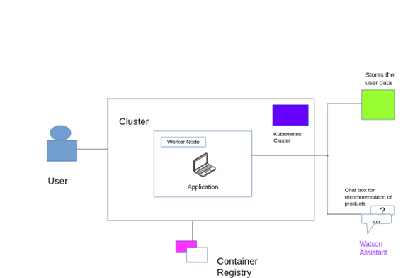**Solution Architecture Diagram:**

